Expanding the Time We Have With Patients Through Poetry
Rafael Campo, MA, MD¹; Mark Doty²
Author Affiliations Article Information
JAMA. Published online September 27, 2018. doi:10.1001/jama.2018.13761
Rafael Campo, MA, MD; Mark Doty
Video (24:05)
Expanding the Time We Have With Patients - The Relevance of Poetry to Clinical Medicine
At the Ninth Annual Hippocrates Poetry and Medicine Symposium, convened in May 2018 at the Northwestern University Feinberg School of Medicine in Chicago, Illinois, physician-poet Rafael Campo, associate professor of medicine at Harvard Medical School, was joined in conversation by National Book award–winning poet Mark Doty, distinguished professor of English at Rutgers University. What follows is an excerpted transcript of the second half of their dialogue, which has been condensed and edited for clarity and concision. The first half of the dialogue appears in another Arts and Medicine article.
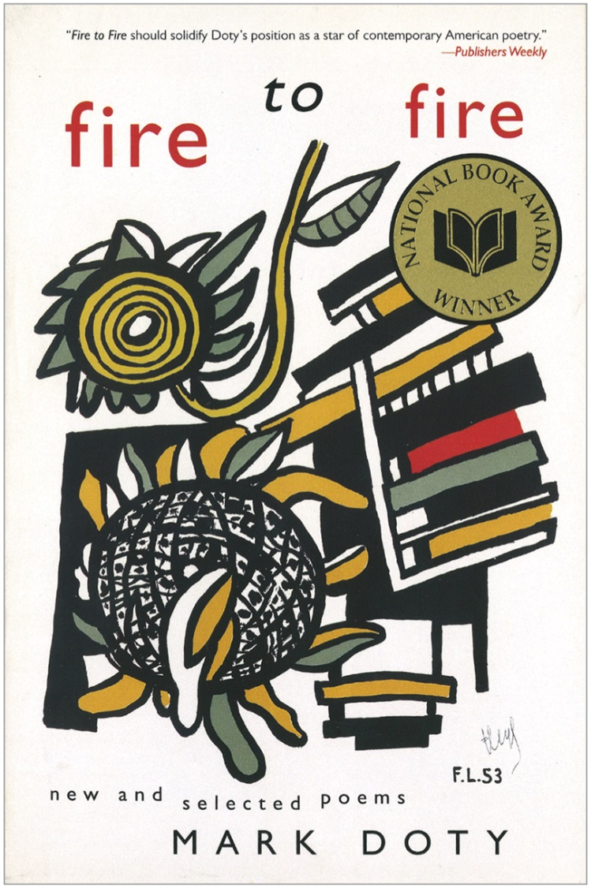
Copyright 2008; Harper Perennial Publishers; New York, New York.
Image courtesy of Mark Doty. Reproduced with permission.
Rafael Campo:I'm wondering how you might see poetry as a way of engaging aspects of the experience of illness that are often edited out of the biomedical approach. Some of the terrible disparities in health among different populations in this country can be explained by lack of attention to the so-called social determinants of disease.
Mark Doty:Poetry can remedy mistaken narratives. I was living in a community very hard hit by the AIDS epidemic and what I saw all around me was compassion and courage; incredible persistence; and people finding ways to get money, food, and attention to other people. What I saw in the newspaper and on television were narratives of abandonment, rejection, and of the isolated disease pariah shuttled off someplace. It was a very dark image of being ill, which would make one think, “That's a death sentence, that diagnosis,” and it had nothing to do with the reality around me. So I wanted to write poems that addressed that generosity, and poetry can remedy narratives that put too much emphasis in one place. Another role for poetry is that there is an intrinsic pleasure when people talk about poems together as long as nobody is saying, “I know what this means and you don't,” [but rather] “The meaning is what we make right now out of what we read.” People love doing that—reading poems, comparing their own experience, finding themselves in it. And that's the way we start crossing lines: gender, age, economic shifts, and race. All kinds of boundaries get dissolved when we look at the work of art one person has made to say “Here's how I perceive the world, Here's a record of my voice in this moment—in this confusing, conflicted, difficult place we're in.” No other art can do quite that, can give you so much the feeling of hearing the inner voice of another person and being able to feel a little closer to what it's like to be them.
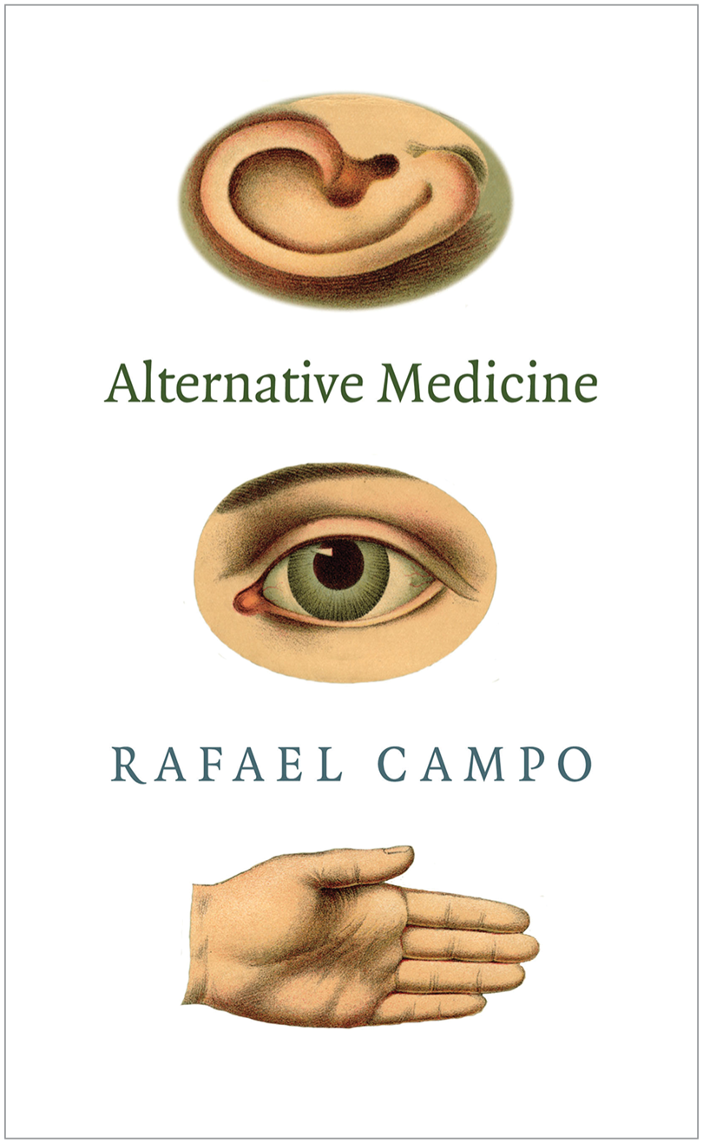
Copyright 2013; Duke University Press; Durham, North Carolina.
Image courtesy of Rafael Campo. Reproduced with permission.
RC:I think you just helped me understand why, when I teach seminars on health disparities and present the faceless statistics, the eyes of my students glaze over and there's a feeling of hopelessness and helplessness: “This doesn't affect me, these are those other people.” But when we share a poem, it's extraordinary because literally the discussion shifts to How am I implicated? How do I see these injustices, these disparities through the lens of my own experiences? That empathic possibility in the experience of sharing a poem is really extraordinary. And I think those poems have an amazing sort of instructive value, certainly in the teaching of health disparities to our medical trainees.
MD:Every act of valuing the voice of another person, of really hearing it, listening to it, taking it seriously, sharing it is an act—well, it's a blow against the empire. You’re a doctor reading and studying poetry, but one thing to bear in mind is that there's a poetry culture and poets will talk one way; there's an academic culture which will speak about poetry in another way; and [persons in] medical humanities will use poetry differently. So much the better. More discourses. And we don't have to privilege any of them over the other, right? It's all about how we make use of the art. I guarantee you that nothing will make poets happier than the idea that you use their poems in a way that truly makes a difference in the world.
Audience Question: As a practicing physician, I am fascinated with how you use poetry with your patients. Can you give an example?
RC:Sure. [I was caring for] a patient who had unexplained liver failure. He had a severe variceal bleed and looked like he was going to die. I've taken care of him for 35 years and we've talked poetry in informal ways through those many years, and as we were confirming [his] dire outcome he asked “Can we read a poem together?” And we shared a poem that he had written in that setting as a kind of a legacy, as something he wanted to give [to his family] if he didn't survive. Miraculously, he survived. So he's coming to our next clinical appointment with the poem that we talked about, and he wants to read it again with me. For him, it's become an emblem of his survival. That was just one of those extraordinary moments where I felt that the poem had something to do with how we could be present together at what appeared to be his imminent death, how it was a comfort to us, and how now it's taken on a different kind of meaning. Sometimes our interactions in medicine are so time limited, we're so pressured for time—that's one thing that I get from my colleagues all the time is, “Now you want me to read a poem? I mean, here's my checklist, where does poetry go on my checklist?” But you know, sometimes that poem expands the time we have with our patients.
MD:I would not be at all surprised to know that that space, that connection, is some element of his survival.
RC:I hope so because I think it certainly was meaningful to both of us.
MD:And if it's not, it still has that meaning, right? It made his time better.
Editors’ Note: Part 1 of the dialogue appears in an accompanying Arts and Medicine article and Video. Some identifying details were changed by Dr Campos in his description of his patient.
Video. Poetry and Medicine. Rafael Campo and Mark Doty in conversation at the Ninth Annual Hippocrates Poetry and Medicine Symposium, May 11, 2018, at Northwestern University Feinberg School of Medicine in Chicago, Illinois.
Submissions: The Arts and Medicine editors welcome proposals for features in the section. Submit yours at artsandmedicine@jamanetwork.com.
Back to top
Article Information
Corresponding Author: Rafael Campo, MA, MD, Division of General Internal Medicine, Beth Israel Deaconess Medical Center, 330 Brookline Ave, Boston, MA 02215 (rcampo@bidmc.harvard.edu).
Published Online: September 27, 2018. doi:10.1001/jama.2018.13761
Conflict of Interest Disclosures: All authors have completed and submitted the ICMJE Form for Disclosure of Potential Conflicts of Interest and none were reported.

